BIDDULPH COMMUNITY EMERGENCY PLAN

VERSION 5
UPDATED – MAY 2023

In the event of an emergency, the first vital action is to dial 999.
This document can then support action that will follow.
Name of Community | Biddulph
Biddulph Community  Emergency Plan Coordinator (EPC) | Councillor Dave Hawley
Plan Adopted by | Biddulph Town Council
Date of First Adoption | 16 May 2023

Version Control

Issue or Change Date | Issue or Change No. Pages Amended and Nature of Change | Date of Issue/ Change distributed
V1 March 2021 | Document created.
V2 October 2021 | Inclusion of ‘Ambulance’ on p7, roles within the community.  Inclusion of potential safe spaces | 18 October 2021.
V3 December 2021 | Risk assessments added as appendices
V4 July 2022 | Final amendments | 4 July 2022
V5 May 2023 | Councillors amended

Distribution

When this Plan is updated, the revised version is sent to:
- All Councillors and Officers of the Town Council
- Staffordshire Moorlands District Council (inc. relevant Councillors)
- Staffordshire County Council (inc. relevant Councillors)
- Staffordshire Police
- West Midlands Ambulance Service
- Staffordshire Fire and Rescue Service
- Local Health Centre managers

Contact information for Officers and Councillors is contained within this Plan. This information is not available to the wider public.

This Emergency Plan considers the activities and responses across the five wards of Biddulph:
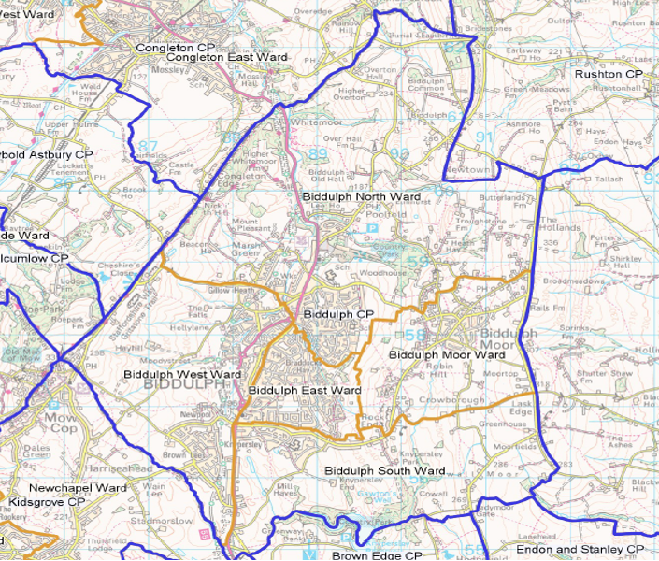

Biddulph Town Council works collaboratively with partners in the town to ensure fair, appropriate and accessible services are provided to the people who live here. The infographic below shows who is responsible for many of the key statutory and non-statutory services within the town:

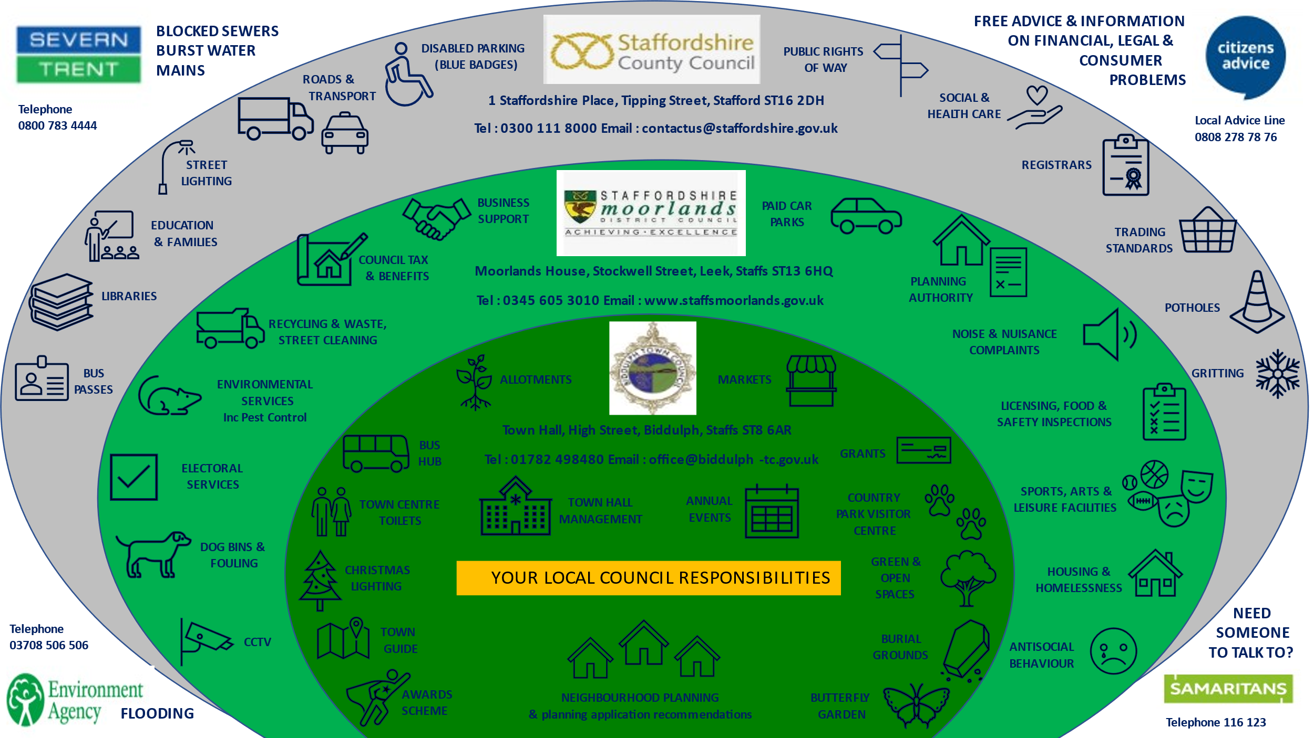

Foreword

Background and introduction
In 2020, Biddulph and the rest of the world faced an unprecedented challenge, managing our services and supporting our community in the face of a global pandemic. Councillors at Biddulph Town Council met virtually for a period of time, and agreed during this period that they wanted to proactively plan for events in the town, building resilience amongst communities.

There is no statutory requirement to produce this document, but a Community Emergency Plan document has the ability to set out how a community would respond to an emergency situation e.g., while awaiting the assistance of statutory authorities /emergency services, or in support of them. This Plan will be reviewed annually.

Definition of an emergency
An emergency/major incident is any event or circumstance (happening with or without warning) that causes or threatens death or injury, disruption to the community, or damage to property or to the environment on such a scale that the effect cannot be dealt with by the emergency services, local authorities and other organisations as part of their normal day-to day activities.

Aims and Objectives

Aim To increase the readiness, responsiveness and resilience of the Biddulph community during any major emergency in the town by establishing an organisation, management structure and procedures capable of reacting quickly and effectively at no notice.

Objectives
      - To identify the risks to the community and those who might be most vulnerable.
- To increase the preparedness and resilience of the community, enabling it to respond quickly and effectively to any major incident, accelerating the resumption of normal operations.
- To provide an up-to-date and accessible database that includes key personal contacts, and the location of key buildings and facilities in the town, ensuring the appropriate resources are available to assist in an emergency.
- To identify where it may be possible to reduce potential harm or damage, both immediately and in a planned way over a set period of time, to individuals, buildings and the environment.
- To build on the tremendous community spirit that is so evident within the town, to encourage neighbours to look out for each other and provide emergency support if needed.

Roles within the Community

Biddulph Town Council
The Biddulph Community Emergency Plan has been developed by Biddulph Town Council and is separate from, but complementary to partner agencies’ Major Incident Plans. This document seeks to organise community self-help, and to respond to requests for community assistance from Staffordshire Moorlands District Council or other members of the Local Resilience Forum. Biddulph Town Council will oversee this activity within the community.
An important aim for the Town Council will be to ensure that people most at risk or in need of help are identified and receive help in good time. This includes any potentially vulnerable people who are not normally seen regularly (e.g., daily) by visiting Social Services, medical staff or neighbours, but who may need urgent help in periods of extremely cold weather, a prolonged heatwave, a serious epidemic or pandemic, or during a widespread loss of electrical power, other utilities or telephones. Not receiving help in time could have very serious consequences.

Good Neighbours, Voluntary and Charitable Organisations, Clubs and Societies
Voluntary organisations, clubs and societies can make an important contribution by keeping in regular touch with their members to find out whether any are in need of help, and also by responding positively to any calls for volunteer assistance requested by the Emergency Incident Room (EIR). Also, individuals and organisations with useful skills, equipment or facilities, may wish to offer these through the EIR. Volunteer effort can range from responding to calls for workers in Rest Centres, to knocking on doors to find out whether potentially vulnerable people require help.
Help could also include emergency shopping or arranging car lifts for elderly or disabled people to keep medical or dental appointments; alerting Social Services to new cases of people requiring assistance; clearing snow from and gritting or salting dangerous pavements, driveways and side roads; removing fallen trees or branches - doing anything that will help individuals in the community who, without help, might suffer needlessly. The Biddulph Community Emergency Plan is aimed at enabling the community to prepare to look after itself as much as possible in a major emergency, allowing stretched Emergency Services, Public
Services and Utility Companies to concentrate on dealing effectively with those most seriously affected.

Known Local Hazards- Assessment

In preparing this Emergency Plan, Biddulph Town Councillors completed an exercise to map potential hazards, considering their impact and how the Town Council can seek to mitigate these risks. The tables below are the outcome of this work:

Issue identified | Likelihood | Impact | Consequence | Action/ Mitigation | Notes
Snow | Medium | Medium | Blocked Roads (A527); gritters can’t get through; Biddulph Moor cut off; emergency services unable to access; power cuts; carers can’t visit those needing support. | Local volunteers/ farmers to clear roads; refer to Winter Management Plan. | Winter Management Plan reviewed annually by Finance Management and Strategy Committee.
Telecoms issues | Medium | Medium | No Wi-Fi/ phones | Contact relevant authorities; contact list for Council; emergency services to broadcast messages; access to mobile PA system. | Town Council to look at purchase of mobile PA system.
Tree die-back/ destruction | Medium | Low | Need to replace trees (potential high cost); impact on water/ flooding; loss of trees after storms; road closures. | Clear area to stop spread; tree inspections after storms; identify contacts to clear destruction. | The Town Council has an annual tree inspection.
Loss of local school | Low | High | Affect ability of local children to learn. | Make Town Hall available; refer to local schools- do they have a plan and does it include Biddulph Town Council. | Further investigation needed with local schools.

Extreme heat | Low | Medium | Fires; vulnerable people suffering with heat exposure. | Liaise with emergency services to provide visiting support.
Mineshaft collapse | Low | Medium | Collapse of roads, gardens and houses. | Support with closing roads and providing diversions; contact aid services.
Pandemic | Medium | High | Death and illness. | Similar actions as with Covid-19 pandemic; recruit and manage volunteers; make Town Hall available; refer to Biddulph Town Council Business Continuity Plan (BCP). | The Town Council has a separate BCP; reviewed annually. As part of the Covid-19 pandemic, the Town Council delivered 2500 prescriptions and liaised with a wide range of stakeholders.
Inappropriate waste disposal | Medium | Medium | Potential contamination; encourages more inappropriate dumping | Refer to Staffordshire Moorlands District Council (SMDC) and/or Staffordshire County Council (SCC); ensure contacts are up to date; query Town Council responsibilities. | Town Council to be clear about reporting and escalation processed.

Fire or explosion | Medium | Medium | Loss of life/ injury; day-to-day operation of affected buildings. | Refer to emergency services; make Town Hall available; refer to Town Council BCP; staff and Councillors to be available.
Groundwater contamination | Low | Low | Risk to people/ animals that come into contact; potential contamination of land/ water. | Contact environmental services; contact numbers for water authorities.
Extreme Cold | Low | Medium | Vulnerable adults will suffer. | Refer to Winter Management Plan; address levels of poverty to enable households to stay warm; consider use of the Town Hall; Town Council to provide emergency food and warmth. | Consider good practice examples of emergency food and warmth provision.
Terrorism | Low | Medium | Loss of life/ injury; day-to-day operation of affected buildings. | Refer to emergency services; make the Town Hall available; contact lists for relevant groups and individuals.

Flood/ wind | High | Low | Displacing people; loss of roads- infrastructure and services; major traffic congestion; loss of deliveries to local businesses (inc. supermarkets); temporary accommodation required. | Plan diversions; source materials to alleviate; provide temporary accommodation; liaison with services/ utilities; preventative landscaping.
Major incident on A527. | High | Medium | Loss of life; traffic issues; major traffic congestion; emergency service access blocked. | Liaison with emergency services; look at planned diversions.
Hazardous material spills | Medium | High | Toxicity; evacuation; road closures | Require list of local businesses and contacts for toxic/ dangerous materials; consider temporary accommodation; create diversion plan; effective communication with residents through website and social media. | Town Council to create a log of items within the town that are potentially hazardous.  Investigate what the regulations are around emergency road closures/ diversions.
Loss of water/ power | Medium | High | Poor hygiene; no drinking water; potential evacuation needs; heat/ cold risk; loss of communication; panic amongst residents. | Explore emergency power for essential services; emergency generators; effective communication with residents through website and social media; liaison with utility companies; liaison with emergency services. | Review partner plans regarding emergency power: do they consider the provision of emergency generators?
Rising water table | Medium | Medium | Potential flooding. | Plan diversions; source materials to alleviate; provide temporary accommodation; liaison with services/ utilities; preventative landscaping.
Falling materials | Medium | Medium | Blocked roads/ footpaths; dangerous buildings; loss of life/ injury. | Ensure equipment to screen off building is available; road diversions; tree surveys completed; building/ land inspections take place where concerns are raised; work closely with emergency services.
Biohazard contamination | Low | High | Risk to people/ animals that come into contact; potential contamination of land/ water. | Contact environmental services; contact numbers for water authorities.

Aircraft crash | Low | High | Loss of life; loss of business/ public buildings/ roads. | Consider management of burial grounds; make Town Hall available; refer to emergency services plans. | Town Council to monitor changes with flight paths; review partners’ plans.
Inappropriate development | Low | Medium | Poor structures; non-compliant development could create hazards to community and their property. | Ensure Environmental Health, Planning Enforcement and the Police are all involved.

Activating the Biddulph Community Emergency Plan

An Emergency Plan activation request may be received from one of the following agencies external to Biddulph:

- By a telephoned request from the Staffordshire Resilience Forum (SRF) to the Chief Officer (in normal working hours), or, out of normal hours and at weekends / public holidays, to the Biddulph Emergency Plan Coordinator (EPC), Councillor Hawley , or ifs /he is un-contactable, to one of the Deputy Emergency Plan Coordinators (DEPCs).

- By a telephoned request from Staffordshire Moorlands District to the Chief Officer or the Biddulph Community Emergency Plan Coordinator (EPC), or if un-contactable, to one of the Deputy Community Emergency Coordinators.

- By a telephone request from one of the Emergency Services to the Chief Officer or Biddulph Community Emergency Plan Coordinator, or if un-contactable, to one of the Deputy Community Emergency Plan Coordinators.

Alternatively, the Emergency Plan may be activated from within Biddulph by the Emergency Plan Coordinator (EPC) after consultation with whichever Deputy Community Emergency Plan Coordinators (DEPC) can quickly be contacted. The Town Mayor or in his/her absence the Deputy Mayor should also be consulted if practicable. The decision process to activate should be based on reliable local information or first-hand knowledge of the obvious severity of the Emergency situation or Incident.

The decision should be taken following agreement at a discussion involving the EPC and/or one or available DEPCs and the Town Mayor (if contactable). The EPC or DEPC should inform the Duty Officer at Staffordshire Moorlands District Council or the Staffordshire Moorlands District Council Emergency Centre, whenever the Emergency Plan is activated, giving the reasons, and the Telephone No. and Email address of the Emergency Information Room (EIR) or Primary Contact Point and person (if the EIR is not yet or not being activated). All Councillors in the Call-Out Tree should be informed of its activation.

Telecommunications Blackout

Should there be a total telecommunications blackout in Biddulph, the Emergency Coordinator and/or Deputy Coordinators (as appropriate) should take the decision to activate the Emergency Plan after verbal agreement with at least the Town Mayor or Deputy Mayor, and if possible, the Chief Officer, at an emergency person-to-person meeting.

Decision Taken to Activate the Biddulph Community Emergency Plan – Immediate Actions

- Select or confirm the most suitable location for the Community Emergency Incident Room (EIR). The preferred location is the Town Council Offices, Biddulph Town Hall (ST8 6AR).
- Open a Log and note what actions taken and when

- Notify all Councillors (and any others) listed on the Biddulph Community Emergency Plan Call-Out Tree that the Biddulph Emergency Plan and Incident Room (if appropriate) are being activated. If appropriate, request Councillors’ presence at the Council office (or other location close to or at the EIR itself) for an Emergency Meeting. (Note: this will be an Emergency meeting and not a Council meeting.)

- The EPC and/or DEPC or Chief Officer should collect the Emergency Incident Room Emergency Pack, and set up and open the Emergency Incident Room.

- In addition to the Chief Officer and the EPC/ DEPCs, identify volunteer Councillors willing to assist with manning and administering the Community Emergency Incident Room (EIR).

- Notifying Local Public Agencies that the Emergency Information Room (EIR) is in Operation.

As soon as the Emergency Incident Room (EIR) is operational, the EPC / DEPC, Chief Officer or her assistant on duty should refer to the List of Useful Emergency Contacts, and telephone or email to inform each that:

1) The Biddulph Community Emergency Plan has now been activated, giving the cause
2) The Emergency Incident Room is operational, the EIR location, contact telephone number, email address and opening hours (normally 24-hours/day), and that:
3) The Emergency Incident Room (EIR) is until further notice their primary point of contact with Biddulph Town Council and matters relating to the Biddulph Community Emergency Plan and the present Emergency Situation.

Emergency Call Out Tree

EPC Cllr Hawley
Cllr Rushton
Cllr Hopkins
Cllr Wood
Cllr Brady
Cllr Salt
VACANT
Cllr Kisicki
Cllr Proudlove
Cllr Smith
Cllr Holdsworth
Cllr Eardley
Cllr Yates
Cllr Parkes
Cllr Fletcher
Cllr Garvey
Cllr Harper
Community Reps
DEPC- Cllr Jones (Moor)
DEPC- Cllr Jackson (East)
DEPC- Cllr Lawton (South)
DEPC- Cllr Rogers (West)
DEPC- Cllr Hart
(North)
Chief Officer

Designated Rest Centre(s)- Potential Places of Safety

District/ unitary councils are responsible for setting up a central rest centre during an emergency. However, it may be necessary to set up a temporary place of safety within the community as an option e.g. for visitors or for people evacuated from their homes.

Large public venues within the town include:
Biddulph Town Hall, Biddulph Valley Leisure Centre, Biddulph Youth and Community Zone, Biddulph Methodist Church and schools.

The following items will form part of an Emergency Pack, maintained by the Town Council staff team and checked annually. These items will be transferred to the Place of Safety following activation of the Emergency Plan:

- A USB stick containing the current version of the Biddulph Community Emergency Plan and any other useful community information.
- Two printed copies of the current version of the Biddulph Community Emergency Plan
- A large-scale street map of Biddulph for wall display
- Log Sheets to record actions.
- A ream of paper and pens
- An up-to-date Register of Electors
- A list of Biddulph Post Codes, listed by road.
- A wind-up radio for the Incident Room (or battery-operated with spare batteries)
- Four wind-up torches or battery-operated torches with spare batteries.
- Six hand-held two-way radios with chargers and each with a spare battery, one as a Base Station, four for the Emergency Coordinators to communicate with the EIR, plus 1 spare (can be a second radio in the EIR).
- Direction pointers and Notices that can be positioned, indicating the location of the Emergency Incident Room for visitors.
- Up-to-date Telephone Directory and Yellow Pages.
- A copy of the Biddulph Official Guide and a list of organisations

Information provided as part of a briefing

At the earliest opportunity, the Chief Officer will provide the following information.

- Current Situation
- Nature of the Emergency or Incident
- Road / Street names directly affected?
- What critical and key buildings / sites are in the affected area?
- How badly are they affected? Identify significantly affected buildings / sites.
- Are any main access routes to directly affected areas impassable or limited?
- Is public transport affected?
- Is there any threat to life?
- Have electricity, gas or water supplies been affected?
- Have landline / mobile telephone and/or radio communications been affected?
- What can we safely do now without the help of (and without hindering) the Emergency Services and Local Authority?
- Is our Community Emergency Incident Room open, manned and fully functioning?
- Has contact been made with local media? Are there any specific messages we should request them to put out? Do we know what messages have been put out by the media already?
- Is there a need for an immediate or early evacuation? If so, from where?
- Is it possible that an evacuation might be necessary in a few days’ time?
- How many people will / may require evacuation?
- Are any known vulnerable groups of people directly affected, about how many and where located:
- Elderly and frail
- School children and staff
- People with disabilities of one kind or another
- Non-English-speaking people
- Other vulnerable people (identify)
- What agencies need to be contacted for assistance?
- May any of the following resources be needed, where, and who will take the lead in each case?
- Drinkable Water?
- Hot food and Drinks?
- Medical assistance including First Responders or First Aid?
- Blankets?
- Stretchers?
- Wheelchairs?
- Body-bags?
- Shelter (sex & age groups)?
- Water pumps?
- Sandbags?
- Portable air dryers?
- Motor transport, coaches, ambulance-type vehicles, including lifts for elderly and disabled etc. people?
- Off-road vehicles?
- Snow removal, salt and/or gritting vehicles, or do salt/grit bins replenishment.
- Tree or branch removal services?
- Earth digging and earth removal equipment and services?
- Emergency Roof and Building repairs?
- Plumbers & Drainage Services?
- Portable electricity generators?
- Electricians?
- Gas Engineers & Services?
- Water utilities and sewerage engineers?
- Walkie-talkie radios?
- Other equipment?
- Are additional volunteer helpers required?
- What can we safely do now, without the help, but with the approval of and without interfering with Staffordshire County Council Services and the Emergency Services?
- For what purposes and are particular skills. Qualifications (e.g., are security or child protection clearances essential)?
- How many people are required – male, female?
- Where needed?
- What are likely to be the best sources for required volunteers?
- Can particular Biddulph-based Clubs, Groups and Organisations be of assistance (e.g., to identify individuals at risk or needing help?
- Have they been alerted or asked to help?
- Should representatives be invited to attend the meeting?
- How can the Biddulph Community Emergency Plan team best support the Emergency Services, if at all?
- Review agreed actions and who is to take the lead in each case.

Actions Recommended for Individuals and
Families to Prepare for Emergencies

The community should be advised to create a Household Emergency Plan to prepare themselves properly for emergencies. Their Plan should include the following important information:

- The name(s) address(-es) and phone number(s) of someone living away from Biddulph who will be a family contact
- Make a list of their most important phone numbers
- Decide and note the means by which their family agree to stay in contact in an emergency
- Decide emergency procedures for any children at school and tell them what to do
- Note down Radio Stations to tune into for local information BBC Stoke, Signal Radio
- Note the following Website on which emergency information will be posted: www.biddulph.co.uk
- Be familiar with how and where to turn off your gas, electricity and water main supplies before they leave.
- Prepare an Emergency Grab Bag and keep it handy. The bag should contain or include the following:
      - The Plan information stated in the seven bulleted items listed on the previous page
      - A battery radio with spare batteries or a wind-up radio
      - A battery torch with spare batteries or a wind-up torch
- A Laptop computer, with charger, if they possess them
- First Aid Kit and Medication
- Bottled water and emergency food, enough for three days
- Copies of important documents in a water-proof bag (e.g. Passport, Birth and Insurance Certificates etc.)

Advice to be given to people who are very likely or have to Evacuate
If there is time, quickly add the following items to their Grab Bag:
- Prescribed Medication and Repeat Prescriptions
- Cash and Debit & Credit Cards, Savings Books, Car Keys,
- Toiletries & sanitary supplies
- Mobile phone & charger
- Essential Infant supplies and spare clothes
- When they leave your home:
- Lock all doors and windows
- Take any pets with you in a pet cage or on a lead
- Don’t return home until you are told it is safe to do so
- Continue to tune into local radio stations for news
- If you are able to, look at the www.biddulph.co.uk website for information
- If you have somewhere safe to stay, go there when told to do so by the Emergency Services
- If you have nowhere to go, inform Staffordshire Moorlands District Council. They will make temporary accommodation arrangements.

Councillor  Confidential Councillor Contact Details | Address | Tel | Ward

To be updated when details are confirmed.

